**JAYPEE INSTITUTE OF INFORMATION TECHNOLOGY**



**Major Project Title:** Employee Mental Health System

| **Enroll. No.** | **Name of Student** | **Batch** |
| --- | --- | --- |
| 20103117 | Nikita Singhal | B4 |
| 20103288 | Tanupriya Pathak | B10 |

Course Name: Major Project Part-II

Course Code: 15B19CI791

Program: B. Tech. CSE

4th Year 8th Sem

**2023 - 2024**

**TABLE OF CONTENTS**

| **Chapter No.** | **Topics** | **Pg No to Pg No** |
| --- | --- | --- |
|  |  |  |
| **Chapter-1:** | **Introduction** |  |
|  | 1.1 Abstract | 6 |
|  | 1.2 General Introduction | 6-7 |
|  | 1.3 Problem Statement | 7 |
|  | 1.4 Objective | 8 |
|  |  |  |
| **Chapter-2:** | **Literature Survey** |  |
|  | 2.1 Integrated summary of the literature studied | 9 |
|  |  |  |
| **Chapter 3:** | **Requirement Analysis and Solution Approach** |  |
|  | 3.1 Proposed Approach | 10-11 |
|  | 3.2 Dataset Description | 11-12 |
|  | 3.3 Accuracy Metrics | 12 |
|  | 3.4 Requirement Analysis | 13 |
|  | 3.5 Implementation Tools and Language | 14 |
|  |  |  |
| **Chapter 4:** | **Modelling and Implementation Details** |  |
|  | 4.1 Design Diagrams | 15 |
|  |  |  |
| **Chapter-6** | **Results, Conclusion, and Future Work** |  |
|  | 6.1 Conclusion | 16-17 |
|  | 6.2 References | 17-18 |
|  |  |  |

**DECLARATION**

We hereby declare that this submission is our own work and that, to the best of our knowledge and belief, it contains no material previously published or written by another person nor material which has been accepted for the award of any other degree or diploma of the university or other institute of higher learning, except where due acknowledgment has been made in the text.

**Place:** Jaypee Institute Of Information Technology, Noida Sec-62 **Signature:**

**Date:** 05-03-24 **Name:**

Nikita Singhal 20103117

Tanupriya Pathak 20103288

**CERTIFICATE**

This is to certify that the work titled “**EMPLOYEE MENTAL HEALTH SYSTEM”** submitted by **TANUPRIYA PATHAK(20103288) AND NIKITA SINGHAL(20103117)** in partial fulfilment for the degree of. B.Tech in Computer Science of Jaypee Institute of Information Technology, Noida has been carried out under my supervision. This work has not been submitted partially or wholly to any other University or Institute for the award of this or any other degree or diploma.

Signature of Supervisor:

Name of Supervisor: DR ANKITA VERMA

Designation: ASSISTANT PROFESSOR (SENIOR GRADE)

Date :05-03-24

**ACKNOWLEDGEMENT**

We would like to express our deepest gratitude to our guide, Dr Ankita Verma for her valuable guidance, consistent encouragement, personal caring, timely help and providing us with an excellent atmosphere for doing research. All through the work, in spite of her busy schedule, she has extended cheerful and cordial support to us for completing this project.

**Signature of Student:**

**Name of Student:** Tanupriya Pathak

**Enrollment Number:** 20103288

**Signature of Student:**

**Name of Student:** Nikita Singhal

**Enrollment Number:** 20103117

**Date :**05-03-24

**CHAPTER 1. INTRODUCTION**

**1.1. ABSTRACT**

Mental health issues have gained increasing recognition as a critical concern in contemporary workplaces. This project addresses this challenge by developing a holistic approach, integrating a predictive model using logistic regression for identifying potential mental health issues in employees, along with a mental health chatbot functionality. The chatbot engages in conversations with employees, assessing their mood and well-being through insightful questions. Furthermore, it offers personalised mood-based song suggestions, leveraging natural language processing (NLP) techniques.

The significance of this integrated project lies in its multifaceted impact, aiming not only to identify mental health concerns but also to provide proactive support through the chatbot's conversational interface. This approach not only addresses mental health problems but also contributes to fostering a positive work environment. The expected outcome is a healthier and more productive workplace, reducing absenteeism and enhancing employee retention.

The project commences with comprehensive data collection, preprocessing, and the development of a Bert model for mental health prediction. Simultaneously, the mental health chatbot functionality is integrated into the system, allowing for real-time interaction with employees. Rigorous evaluation ensures the effectiveness of both the predictive model and the chatbot. While the project focuses on data-driven decision-making and early intervention, it is crucial to emphasise that it does not replace diagnostic or medical advice. Instead, it equips organisations with a comprehensive toolset to address mental health challenges, fostering a supportive workplace culture through conversational engagement and mood-based song suggestions.

## **1.2. GENERAL INTRODUCTION TO THE TOPIC:**

The contemporary workplace landscape has increasingly recognized the paramount importance of addressing mental health concerns among employees. In alignment with this recognition, our project endeavours to create a comprehensive solution that combines a predictive model utilising logistic regression and an innovative mental health chatbot functionality.

The predictive model serves as a robust tool, leveraging logistic regression to analyze historical data and identify potential mental health issues among employees. This model is not intended to replace professional diagnostic or medical advice but is designed to empower organizations with data-driven insights for early intervention.

Furthermore, the project introduces a unique mental health chatbot functionality to enhance the support system for employees. This chatbot engages in meaningful conversations with employees, evaluating their mood and well-being through insightful questions. What sets this chatbot apart is its additional capability to provide personalized song suggestions based on the user's mood. Leveraging natural language processing (NLP) techniques, the chatbot creates a dynamic and personalised experience for users, contributing to their overall mental well-being.

The integration of the mental health chatbot complements the predictive model, forming a holistic solution. By fostering real-time interaction, the chatbot not only aids in early identification of potential mental health issues but also contributes to creating a positive and supportive workplace culture. The envisioned outcome of this integrated approach is a healthier and more productive work environment, minimising absenteeism, and enhancing employee retention.

The project unfolds through systematic stages,predicting the mental health status of employees followed by a conversation with a chatbot assistant. While the project's primary focus is on data-driven decision-making and early intervention, the unique addition of the mental health chatbot brings a human touch to the initiative, offering conversational engagement and mood-based song suggestions to uplift and support employees on their mental health journey.

## **1.3. PROBLEM STATEMENT**

In contemporary workplaces, the prevalence of mental health issues has emerged as a critical challenge impacting employee well-being, job performance, and overall organisational success. Recognizing the urgency of addressing this issue, our project aims to develop an integrated solution that combines a predictive model using logistic regression and a novel mental health chatbot functionality with mood-based song suggestions.

Key Challenges:

* Undetected Mental Health Issues: Traditional methods for identifying mental health concerns may not be proactive enough, leading to undetected issues among employees.
* Lack of Comprehensive Support: Existing workplace support systems may lack a holistic approach, leaving gaps in addressing the diverse mental health needs of employees.
* Employee Well-being Impact: Unaddressed mental health challenges can adversely impact employee well-being, leading to decreased productivity, increased absenteeism, and potential attrition.

Proposed Solution:

Our project proposes an integrated approach that combines a model for early identification of mental health issues and a conversational chatbot with mood-based song suggestion functionality. The objective is to create a supportive environment that not only detects potential problems but also actively engages employees in a positive and personalised manner.

Expected Impact:

* Proactive Mental Health Support: The integrated solution aims to proactively identify potential mental health issues through the predictive model, facilitating early intervention and support.
* Personalised Engagement: The mental health chatbot, with its conversational interface and mood-based song suggestions, offers a personalised and engaging experience to uplift employees' moods and well-being.
* Positive Workplace Culture: The overall impact is anticipated to contribute to a positive workplace culture, reducing absenteeism, improving employee retention, and fostering a healthier and more productive work environment.

## **1.4. OBJECTIVES:**

The objectives of this project are as follows:

**PHASE I(Completed):**

* **Data Collection:** Gather comprehensive historical data on employees, including demographic information, work-related factors (e.g., workload, job role, work hours), and mental health-related indicators (e.g., self-reported stress levels, absenteeism).
* **Data Preprocessing:** Clean and preprocess the collected data, addressing issues such as missing values and duplicate values. This ensures the data is suitable for modelling.
* **Model Development:** Build a BERT based model capable of predicting the likelihood of an employee experiencing mental health issues based on the selected features.
* **Classification:** Classify the employee as suffering from Depression, Anxiety, Frustration or Stress.

**PHASE II:**

* Incorporating a simple conversational agent using natural language processing techniques.
* Song Recommendation based on the user's mood.
* Integration of chatbot and the prediction model in a user friendly application for easy usage.

**CHAPTER 2:LITERATURE SURVEY:**

**2.1. Integrated Summary of papers studied:**

| Authors | Topic | Key Characteristics |
| --- | --- | --- |
| Shivam Sakore, Pratik Jagdale, Mansi Borawake, Ankita Khandalkar | Music Recommender System Using ChatBot | This paper proposes a chatbot that recommends music based on the user's emotional state, detected through supervised machine learning (SVM) and IBM Tone Analyzer API. |
| Anusha , Dr. Srinivasan V, | Chatbot Song Recommendation System | It utilises the Last.fm API for song recommendations and IBM Tone Analyzer API for emotion analysis. The paper highlights the potential of AI for personalised experiences and discusses future directions for chatbot development such as recognizing mixed emotions. |
| Simran Chaudhari , Hrucha Malusare , Aadil Adheesh ,Mokshada Bhadavalkar ,Asma Shaikh | Chatbot with Song Recommendation based on Emotion | This paper combines machine learning (SVM, LSVM, Random Forest, Decision Tree) and deep learning LSTM for chatbot response generation. for a system that detects emotions from text and generates responses . |
| Abid Hassan,M. D. Iftekhar Ali,Rifat Ahammed,Sami Bourouis, and Mohammad Monirujjaman Khan | Development of NLP-Integrated Intelligent Web System for E-Mental Health | This paper proposes a web app for mental health support. It utilises an NLP chatbot with MBTI assessment for initial user classification and offers real-time communication features like chat forums and video calls for user-to-user and user-to-psychiatrist interaction. |

**CHAPTER 3: REQUIREMENT ANALYSIS AND PROPOSED SOLUTION APPROACH:**

**3.1. PROPOSED APPROACH:**

**Phase I: Data Collection, Preprocessing, Model Development, and Classification**

* **Data Collection:** In this initial phase, the project focuses on gathering comprehensive questionnaires for identifying mental health issues in employees and sample answers corresponding to each issue . Using the correct labels and text(sample responses) corresponding to them we create a balanced dataset for phase 1 of our project.
* **Data Preprocessing:** Once the data is collected, it needs to be cleaned and preprocessed to ensure its quality and suitability for modelling. This involves handling issues such as missing values and duplicate entries. Clean data ensures that the subsequent analysis and modelling steps are robust and reliable.
* **Model Development:** With the cleaned data, you proceed to build a BERT based model. This model is designed to predict the likelihood of an employee experiencing mental health issues based on the selected features. ***BERT*** is chosen as it's well-suited for binary classification tasks like determining if an employee is experiencing ***depression, anxiety, frustration, or stress.***
* ***BERT Model Integration:***
* The core of the project revolves around the integration of a BERT (Bidirectional Encoder Representations from Transformers) model, facilitated by TensorFlow. This sophisticated natural language processing model empowers the tool to classify user responses into distinct mental health categories such as depression, anxiety, frustration, or stress. The seamless incorporation of the BERT model enhances the tool's accuracy, allowing it to discern subtle linguistic nuances and provide more precise predictions.

**PHASE II:**

* **Part 1:Mental Health Chatbot**
* Intent Recognition and Text Processing:
  + A pre-trained neural network model analyzes the user's input and predicts the most likely intent based on patterns learned during training.
  + The input is tokenized into individual words, and each word is lemmatized to its base form. This processed input is then used to create a "bag of words" representation.
  + The "bag of words" is a binary vector indicating the presence or absence of specific words in the user's input. This representation allows the model to make predictions based on word patterns.
* Model Prediction:
  + Utilizes a pre-trained neural network to predict the intent class associated with the user's input. The bag of words is fed into the neural network model ('chatbot_model.h5'), which outputs a probability distribution over the possible intent classes. The model selects the intent with the highest probability as the predicted intent.
* Response Generation:
  + Provides contextually relevant responses based on the recognized intent. The chatbot selects a random response from a set of predefined responses associated with the predicted intent in the 'intents.json' file. This randomness adds variability to the bot's replies.

**Part 2: Music Suggestion based on mood**

* Apply nlp algorithms for sentiment analysis on user responses and based on the mood detected suggest songs based on genres corresponding to user’s mood.

**3.2. DATASET DESCRIPTION:**

This dataset contains a collection of conversations related to mental health. It covers various conversational styles, such as casual chats, common questions about mental health, discussions on traditional therapy, and general advice for people dealing with depression or anxiety. The main purpose of the dataset is to train a chatbot model to simulate a therapist, providing empathetic and supportive responses to those seeking emotional assistance.

To train the model effectively, the dataset includes the concept of "intents," representing the core purpose behind a user's message. For instance, if a user expresses sadness, the corresponding intent would be labeled as "sad." Each intent is accompanied by sample messages (patterns) that align with that specific intent, along with corresponding responses that the chatbot should generate. By defining multiple intents, patterns, and responses, the model learns to recognize user intentions and generate appropriate and compassionate replies.

* Key: "intents"
  + Value: This is an array containing a list of intents.
* Each intent:
  + Key: "tag"
    - Value: This defines the intent category, such as “greeting” or “fact”.
  + Key: "patterns"
    - Value: This is an array containing user phrases that trigger the intent, for example, greetings like "Hi" or "Good morning".
  + Key: "responses"
    - Value: This is an array containing potential responses the chatbot can give depending on the user's specific phrase within the intent.

**3.3. ACCURACY METRICS**

**Accuracy score:**

Validation accuracy score is a metric used in machine learning to evaluate the performance of a model on a validation dataset. In supervised learning, a dataset is typically split into two parts: a training dataset, used to train the model, and a validation dataset, used to evaluate the model's performance on unseen data.

The validation accuracy score represents the percentage of correctly predicted labels in the validation dataset. It is calculated by dividing the number of correctly predicted labels by the total number of validation examples. A higher validation accuracy score indicates that the model is better at generalising to unseen data and is less likely to overfit to the training data.

**3.4. REQUIREMENT ANALYSIS**

### **3.4.1 Functional Requirements**

### **Input Requirements**

1. The system shall accept a question as input in natural language format.

2. The Response shall be in the English language.

**Output Requirements**

1. The chatbot shall converse with the user and make a conversation to help them.

2. The chatbot shall suggest songs based on the user's mood for them to relax.

**Software Requirements:**

1. Operating Systems: Windows 7 or above, Linux, MacOS
2. Development Tool: Visual Studio Code

**Hardware Requirements:**

1. Processors: Intel® Core TM i3 processor 7th Generation and above
2. Basic Disk Space: Not much required
3. RAM: Minimum Requirement: 2GB
4. Internet Connection is must
5. CPU: 400MHz processor or above

**Processing Requirements**

**3.4.1 Functional Requirements**

* Mental Health Chatbot:
  + Description: Develop a conversational chatbot that engages with users, asks mood-related questions, and provides support.
  + Objective: Enhance user engagement and provide a platform for users to express their feelings, receiving personalised and contextually relevant responses.
* Mood-Based Song Recommendation:
  + Description: Implement a functionality within the chatbot to recommend songs based on the user's mood.
  + Objective: Enhance the user experience by providing a personalised and positive activity, contributing to their mental well-being.
* Real-time Interaction:
  + Description: Enable real-time interaction between users and the chatbot, ensuring timely support and engagement.
  + Objective: Facilitate immediate assistance and create an environment where users feel supported and heard.
* Deployment and Integration:
  + Description: Deploy the system in the workplace environment and integrate it seamlessly into existing systems.
  + Objective: Ensure that the mental health support system is operational and accessible to users without disrupting regular work processes.

### **3.4.2. Non-Functional Requirements**

* Performance:
  + The system should respond to user inputs within 2 seconds to ensure a seamless and responsive user experience.
* Security:
  + User data(conversation) should not be shared with others.
* Usability:
  + The user interface of the chatbot should be intuitive, ensuring ease of use for employees with varying technical expertise.
* Compatibility:
  + The chatbot should be compatible with commonly used web browsers (e.g., Chrome, Firefox, Safari) to maximise accessibility.
* Integration:
  + The chatbot should integrate seamlessly with existing system.

**IMPLEMENTATION TOOLS AND LANGUAGE**

* **LANGUAGE USED**

Python 3.11.4

* **IMPLEMENTATION TOOLS**

 NLTK 3.8.1

   Scikit-learn 1.2.2

Keras 2.15.0

**CHAPTER 4. DESIGN DIAGRAM**

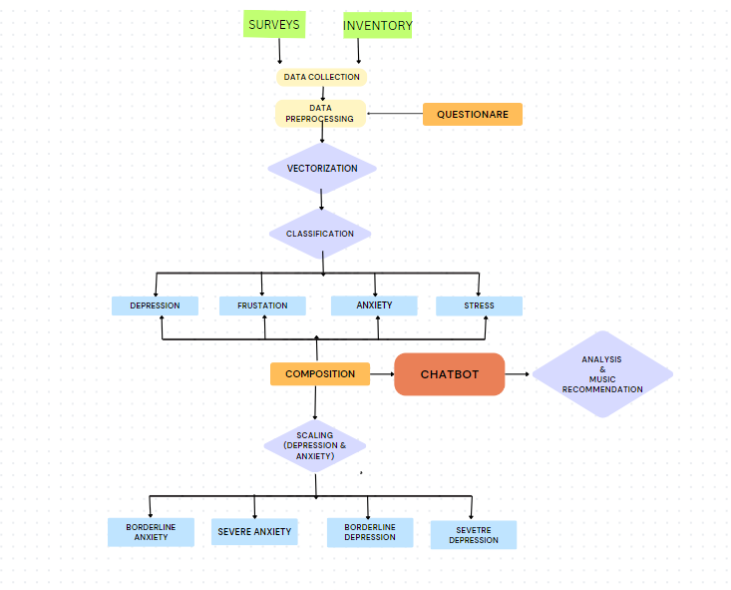

**CHAPTER 6: RESULTS AND CONCLUSION:**

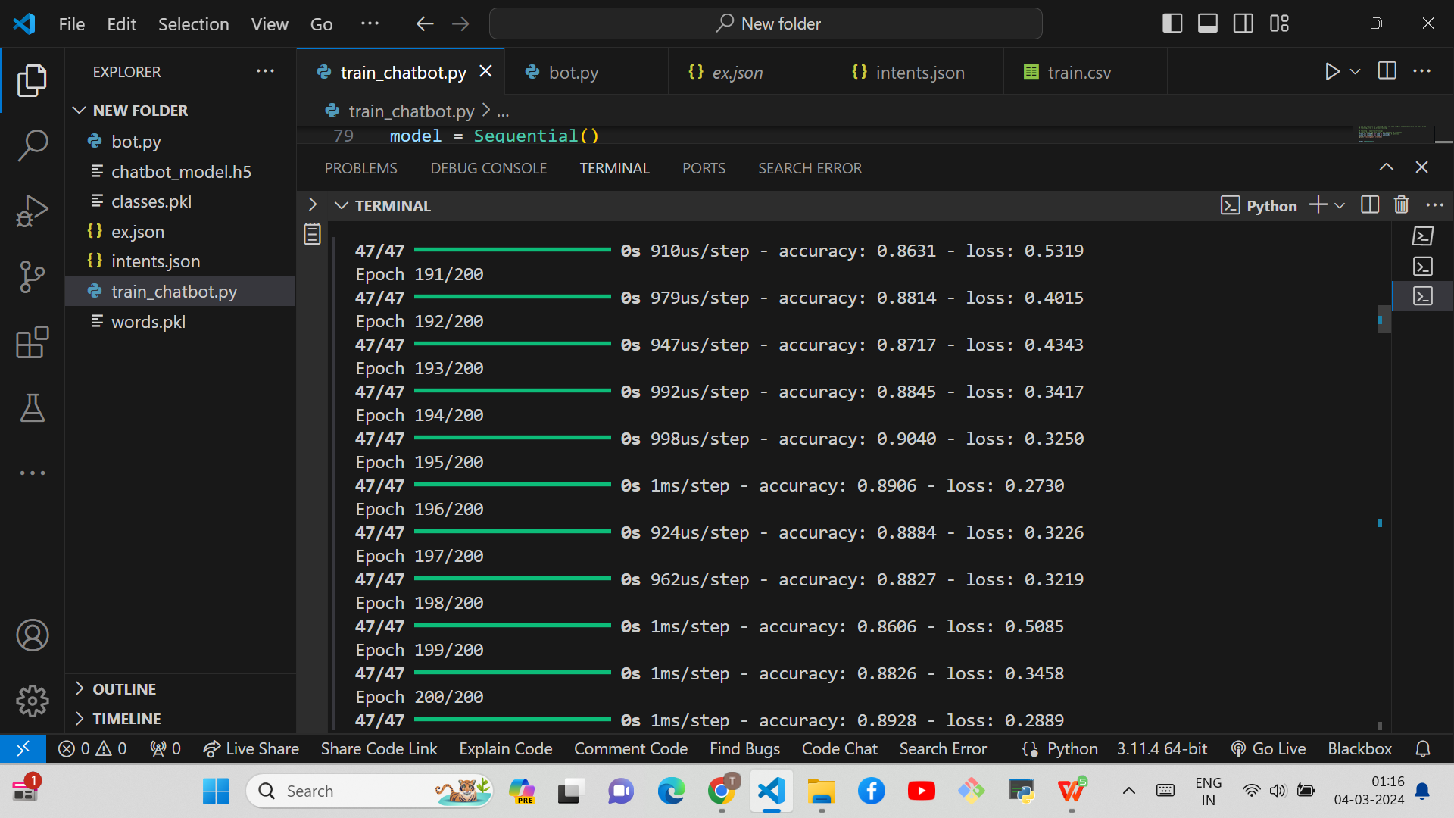

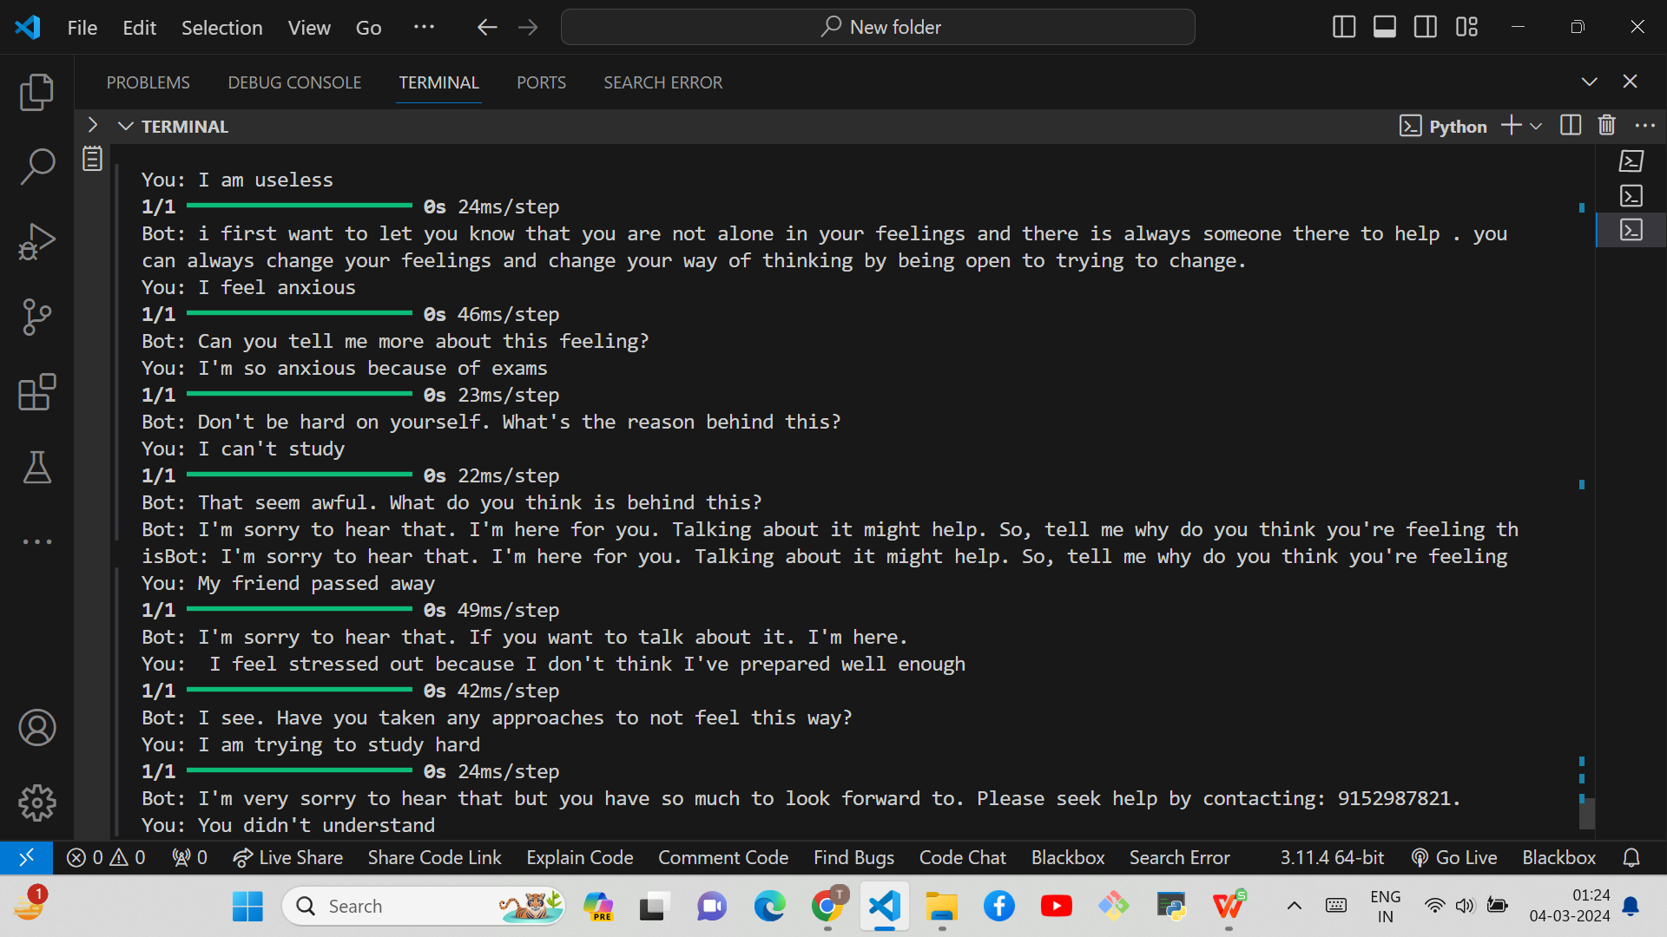

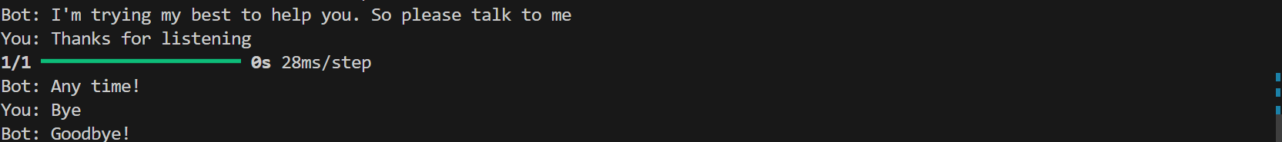

**6.1. CONCLUSION:**

Our project aims to enhance workplace well-being through a blend of technology and empathy. We've developed a predictive model to spot potential mental health concerns early on. Now, we're set to introduce an exciting feature to our user-friendly chatbot – personalised song recommendations based on mood.

This project goes beyond data – it's about creating a workplace where people feel supported. The chatbot engages users in real-time conversations and, soon, it'll be suggesting songs based on their mood to relax. This fusion of tech and a personal touch is designed to create a positive, vibrant workplace, reducing stress, absenteeism, and fostering a stronger sense of connection.

The addition of music recommendations is our way of bringing a tune of positivity to the workplace.

**6.2 REFERENCES:**

[1]. Simran Chaudhari, Hrucha Malusare, Aadil Adheesh, Mokshada Bhadavalkar, Asma Shaikh, "Chatbot with Song Recommendation based on Emotion," *International Journal of Recent Technology and Engineering (IJRTE)*, vol. 3, issue 5, pp. 24-26, [Online]. Available:<https://ijrpr.com/uploads/V3ISSUE5/IJRPR4187.pdf>

[2]. Anusha, Dr. Srinivasan V., "Chatbot Song Recommendation System," *International Journal of Engineering Research & Technology (IJERT)*, [Online]. Available:<https://www.ijert.org/chatbot-song-recommendation-system>

[3]. Shivam Sakore, Pratik Jagdale, Mansi Borawake, Ankita Khandalkar, "Music Recommender System Using ChatBot," *International Journal of Research in Advanced Science, Engineering and Technology (IJRASET)*, [Online]. Available:<https://www.ijraset.com/research-paper/music-recommender-system-using-chatbot>

[4]. Abid Hassan, M. D. Iftekhar Ali, Rifat Ahammed, Sami Bourouis, and Mohammad Monirujjaman Khan, "Development of NLP-Integrated Intelligent Web System for E-Mental Health," *Computational and Mathematical Methods in Medicine*, vol. 2021, article ID 1546343, [Online]. Available:<https://www.hindawi.com/journals/cmmm/2021/1546343/>